Updates made to this document:

Date Created or Updated | Created or updated | User Created or Updated
03/13/2023 | Created | Lori Hammerschmidt

I received notification that I have a document to acknowledge, what do I do?
- Log into UKG Pro (use Apps)
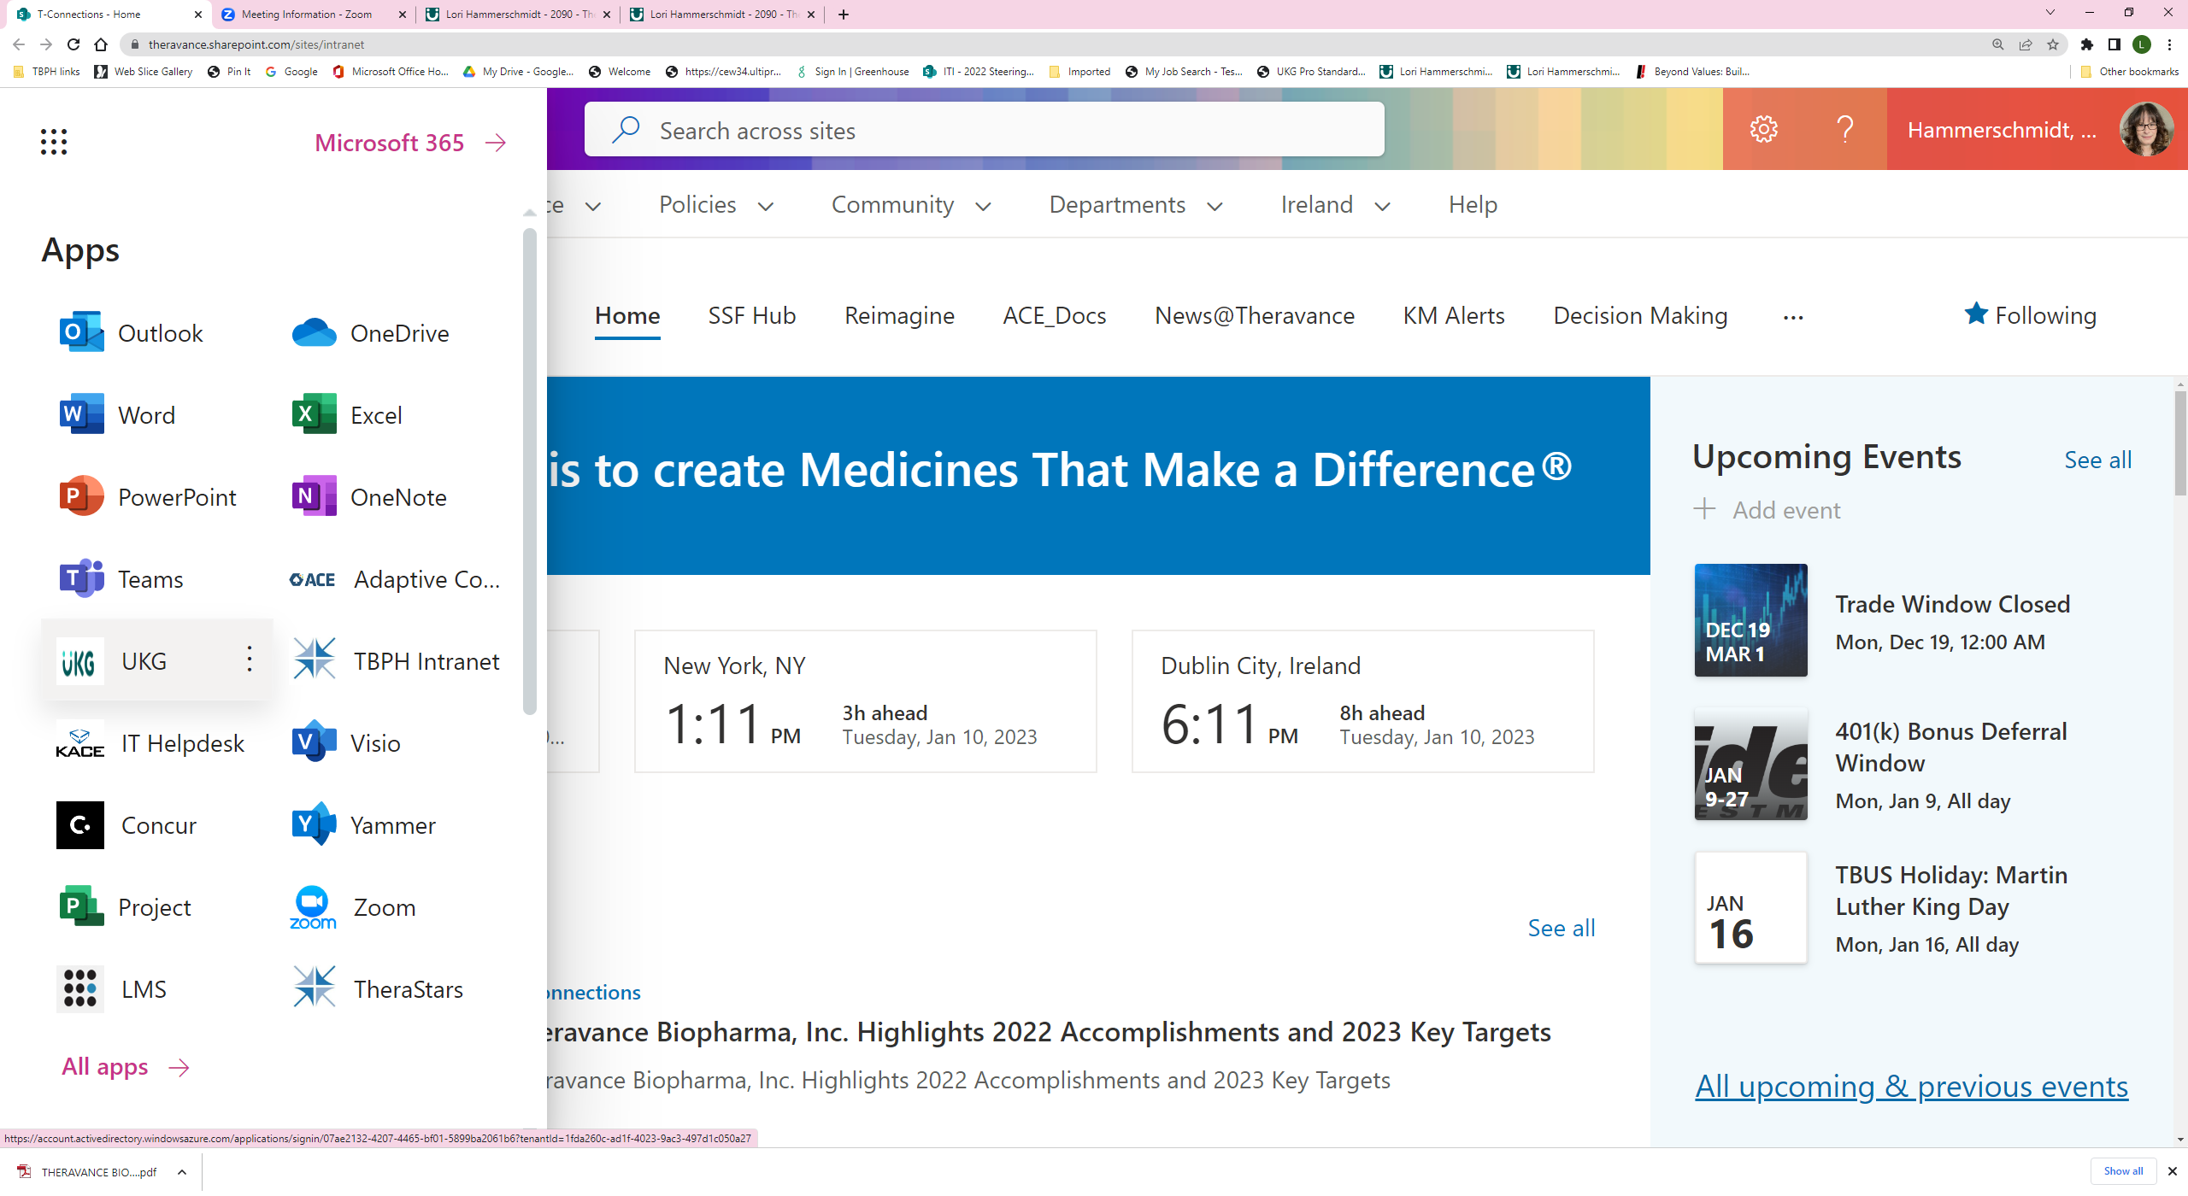

- Notification will display
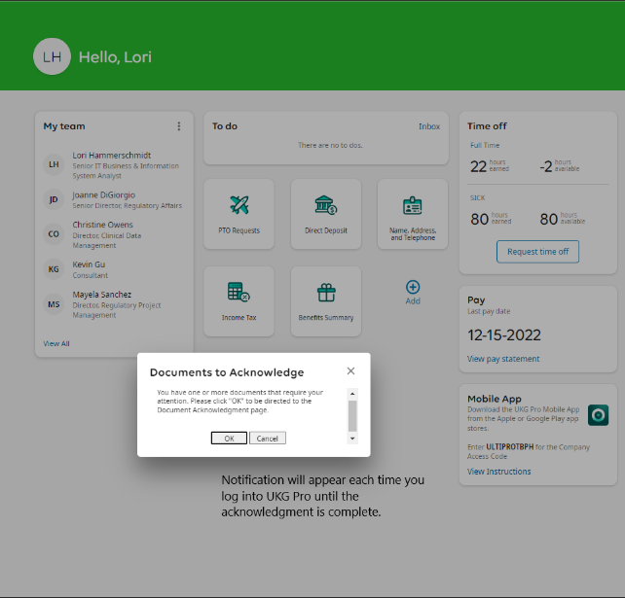
- Click “Ok” -> the system will route you to the Document Acknowledgement page
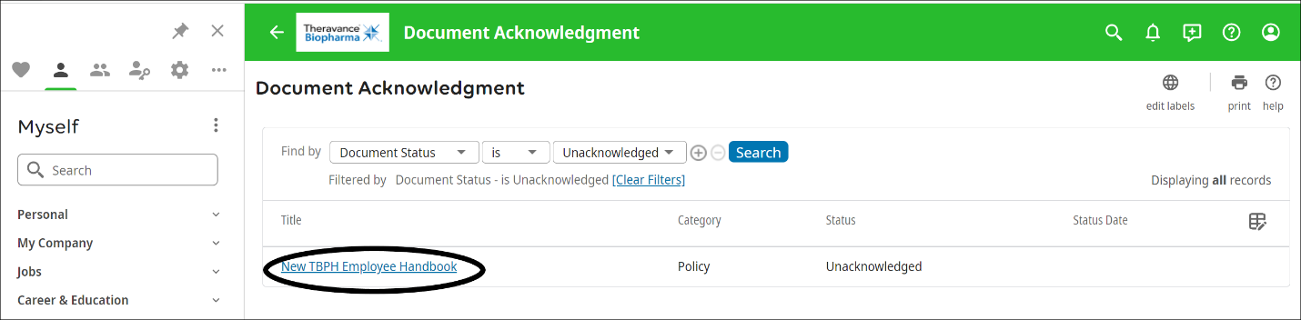

- Select the document to acknowledge (Status: Unacknowledged)
  - Download the document/review (Note: Downloading is a required step)
  - Select “Accept”
  - Click “save”
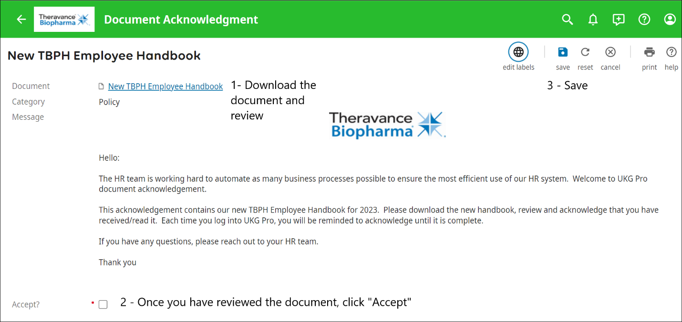

  - Confirm your acceptance
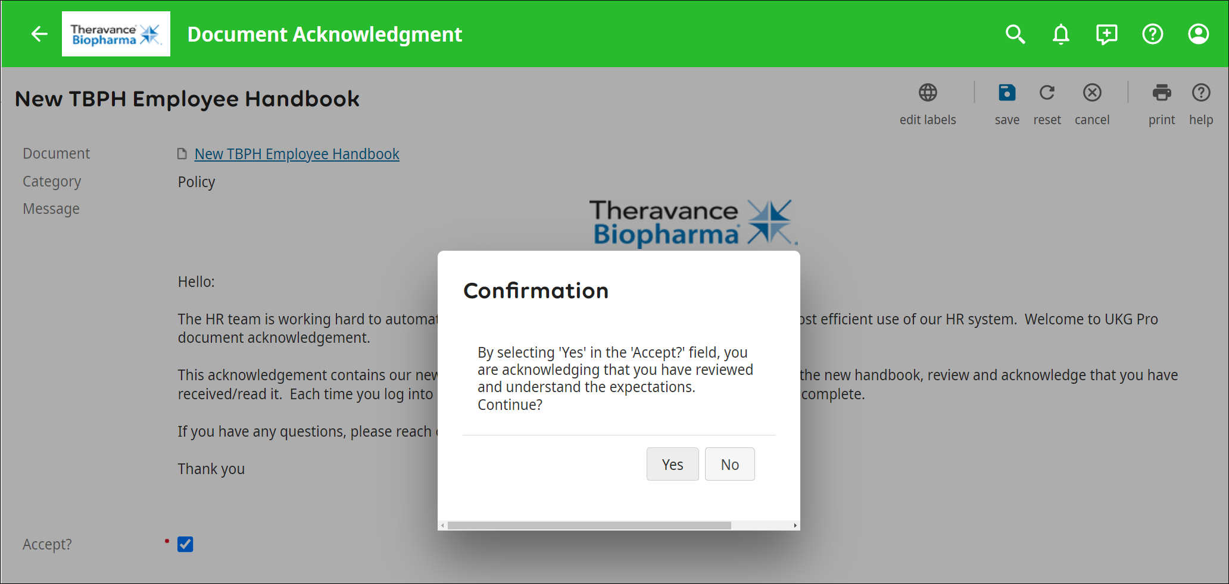

- The completed acknowledgement will be displayed with other acknowledgements that have been completed or awaiting acknowledgement.
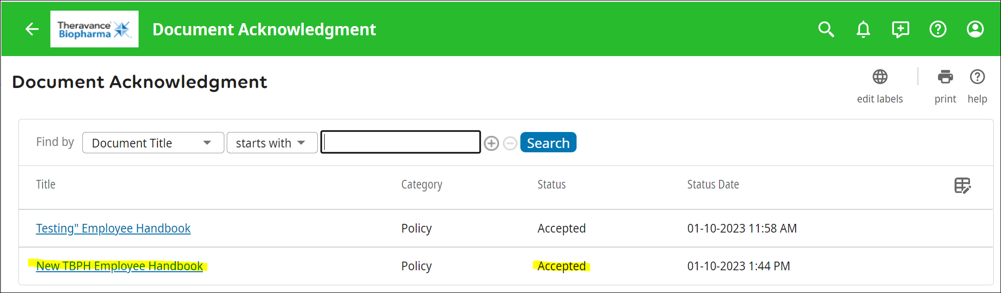

You can locate all document acknowledgments under Myself -> Documents -> Document Acknowledgement

