Updates made to this document:
Date Created or Updated | Created or updated | User Created or Updated
05/22/2023 | Updated | Lori Hammerschmidt
03/02/2023 | Created | Lori Hammerschmidt

I’d like to log into UKG Pro:
- Access TBPH SharePoint
  - Click the 9 box to access My Apps

- Select the UKG icon.
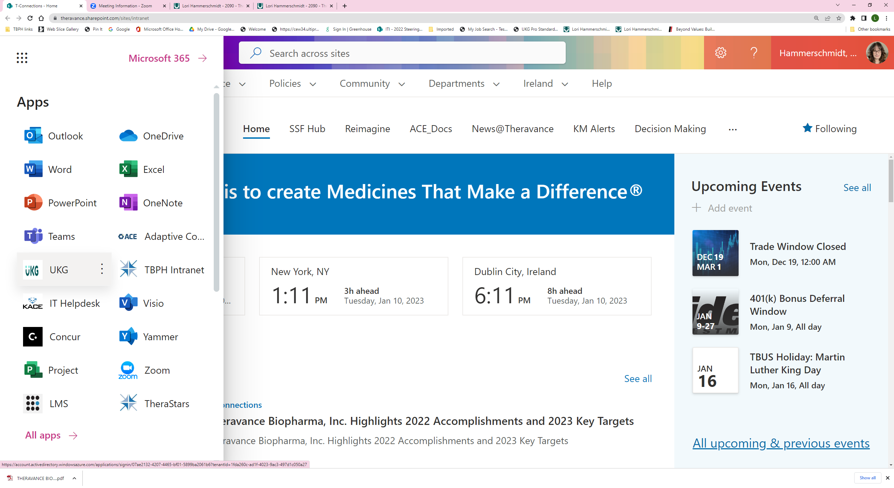
- Your UKG Pro dashboard will display.
