Updates made to this document:

Date Created or Updated | Created or updated | User Created or Updated
02/28/2023 | Created | Lori Hammerschmidt

I would like to change my home address and/or phone number in UKG.
- Log into UKG Pro (use Apps)
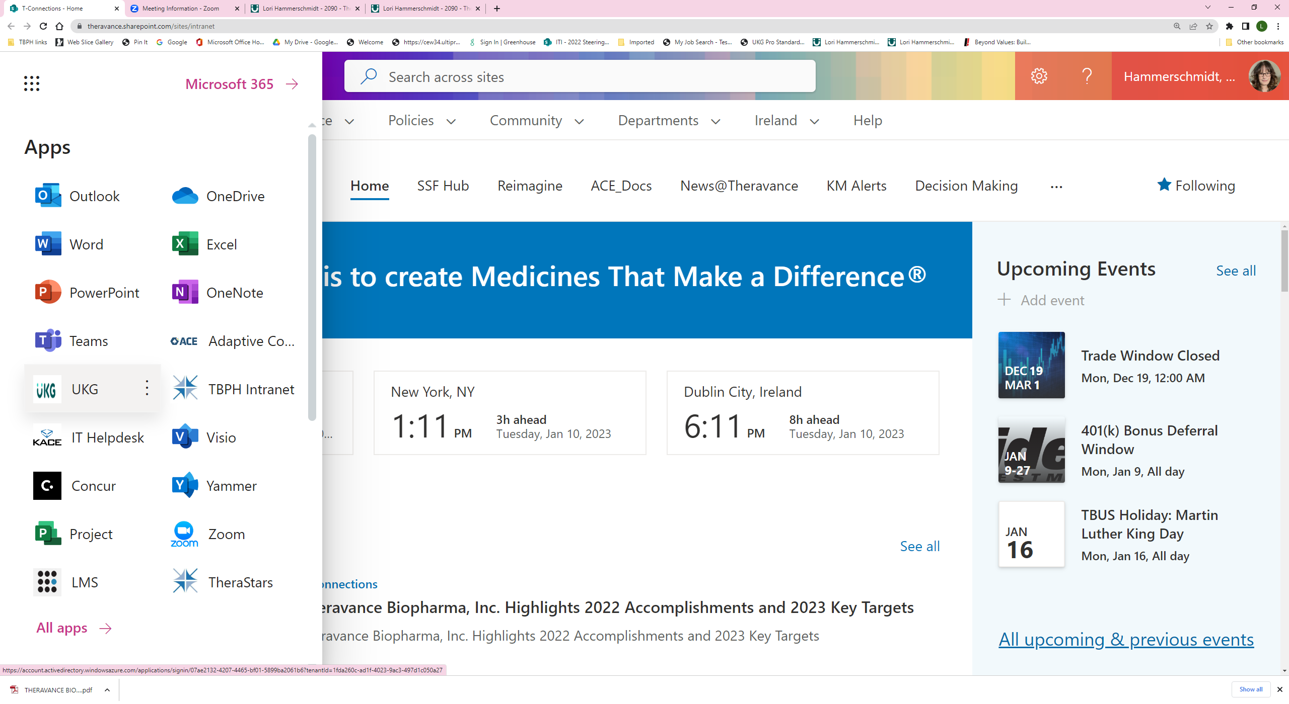

- There are 2 ways to navigate to change this information:
  - Left hand side Menu -> Personal -> Name, Address and Phone Number
  - Shortcut tile on your dashboard
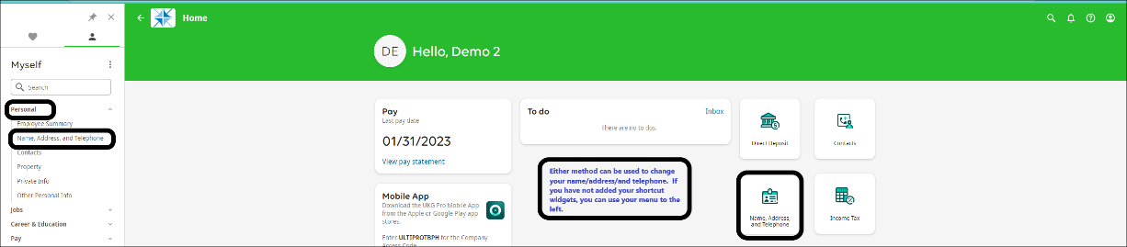
- Under “Things I Can Do” select Change Name, Address and Telephone
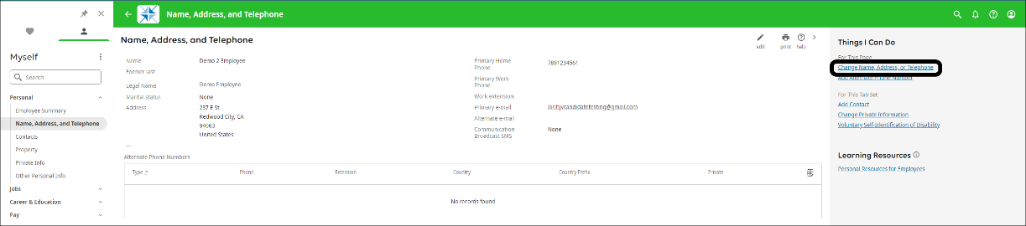

- On the Change Name, Address and Telephone screen:
  - Enter an effective date of the change.
  - Begin to enter the new address in the Quick Address Search bar.
  - Select the correct address that displays in the list.
  - You can also change your home telephone number at this time by changing the number.
  - SAVE
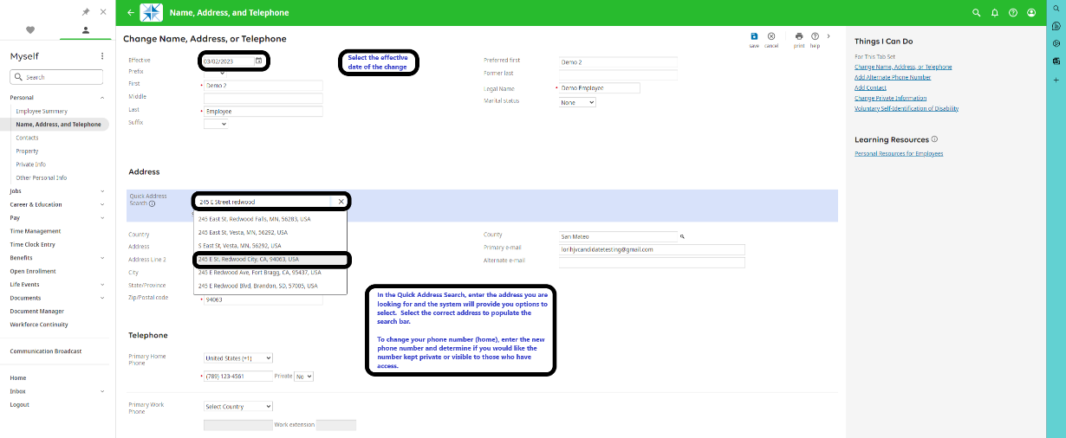

- Review and confirm your changes.
- Select Submit

